A

Project Report on

**“Library Management System”**

Submitted to



Savitribai Phule Pune University, Pune In Partial Fulfillment of

Master of Computer Application (MCA - I, Sem-I)

Submitted by

Mr.Nanavare Pratik Dinkar

Mr.Mulani Shoyab Gulab

Under the Guidance of

Prof. C.N.Reddy

Through



Dr. D. Y. Patil Educational Federation’s

Dr. D. Y. Patil Institute of Management and

Entrepreneur Development.

2024-2025

# DECLARATION

We, the undersigned hereby declare that the project entitled **“LIBRARY MANAGEMENT SYSTEM”,** being submitted for the award of degree **Master of Computer Application(MCA-I, Sem – I)** by we both to **Dr. D. Y. Patil Institute of Management and Entrepreneur Development, Varale, Talegaon, Pune affiliated to Savitribai Phule Pune University, Pune** is the result of an independent work carried out under the guidance of “**Prof. C.N.Reddy”,** is our original work. Further, we declare that this project has not been submitted to this or any institution for the award of any degree.

PLACE: **Mr. Nanavare Pratik Dinkar**

**Mr.Mulani Shoyab Gulab**

DATE:

# ACKNOWLEDGEMENT

The project developed for the MCA was not possible without the persons and organizations that helped both of us in completing this. We deeply grateful to all whose enthusiasm and energy transformed our vision of this study into reality.

We extend our sincere thanks to **Prof. C.N.Reddy** for making it easy to work in the Institute and providing both needed guidance throughout the project keeping it focused and on the track. We are thankful to him for the extended knowledge imparted to both during the course of project development.

We take this opportunity to thank our **HOD Dr. Ashwini Chavan** and our **Director Dr. Priyanka Singh**, for encouragement and guidance throughout the progress of this report.

**Mr.Nanavare Pratik Dinkar**

**Mr.Mulani Shoyab Gulab**

# INDEX

|  |  |  |  |
| --- | --- | --- | --- |
| **Chapter No.** |  | **Details** | **Page No.** |
| **1** |  | **Introduction** | 1 |
|  | 1.1 | Purpose | 2 |
|  | 1.2 | Existing System | 2 |
|  | 1.3 | Proposed System | 3 |
| **2** |  | **Overall Description** |  |
|  | 2.1 | Objective of System | 4 |
|  | 2.2 | Scope of System | 4 |
|  | 2.3 | Modules | 5 |
|  | 2.4 | Hardware and Software Requirements | 6 |
|  | 2.5 | Feasibility Study | 7 |
|  | 2.6 | System Requirements (Functional and Non Functional Requirements) | 8 |
| **3** |  | **Analysis and Design** |  |
|  | 3.1 | UML Diagrams | 10-14 |
|  | 3.2 | Table Structure | 15-18 |
|  | 3.3 | Sample Input and Output Screens | 19-23 |
| **4** |  | **Testing** | 24-28 |
|  | 4.1 | Test Strategy | 24-25 |
|  | 4.2 | Unit Test Plan | 26-27 |
|  | 4.3 | Acceptance Test Plan | 28 |
| **5** |  | **Advantages and Disadvantages** | 29-30 |
| **6** |  | **Conclusion** | 31 |
| **7** |  | **Bibliography** | 32 |

A **Library Management System (LMS)** is a comprehensive software solution designed to facilitate the efficient and effective management of a library's resources, services, and users. In today's digital age, traditional library management, which involves manually tracking inventory, lending, and member records, can be labor-intensive and prone to errors. An LMS automates these tasks, enhancing library operations, improving user experience, and enabling libraries to serve their patrons more effectively. This introduction explores the purpose, benefits, features, and development considerations for implementing a Library Management System.

## 1.1 Purpose:

The primary purpose of a **Library Management System (LMS)** is to streamline, organize, and automate various library operations to improve efficiency, accuracy, and accessibility. Libraries, whether academic, public, or private, have evolved from being just physical spaces for books into dynamic learning and resource hubs. A Library Management System is designed to support this evolution by addressing the many administrative and operational challenges libraries face. Here’s a detailed look at the purpose of an LMS:

**The main purpose of an LMS include:**

* 1. **Efficient Resource Management** : An LMS centralizes information on all library materials, including books, e-books, magazines, journals, and multimedia resources, in a structured digital format. Traditional manual cataloging and tracking methods are labor-intensive and susceptible to human error, often resulting in misfiled items or inaccurate records.
  2. **Enhanced User Experience** : One of the main goals of a Library Management System is to improve the user experience by making library resources easily accessible. With an LMS, users can search for resources, check availability, reserve items, and renew loans remotely, often through a web or mobile interface. This convenience makes the library’s resources more accessible and reduces the need for users to wait in long queues or interact with staff for basic transactions.
  3. **Automating Routine Tasks** : Libraries manage a large volume of repetitive tasks, such as checking out and returning books, calculating overdue fees, and processing new memberships. An LMS automates these routine tasks, significantly reducing the administrative burden on library staff. For example, when a book is borrowed, the system automatically updates its availability status, assigns a due date, and records the transaction.
  4. **Data-Driven Decision-Making** : A Library Management System provides valuable insights into library usage patterns, user demographics, popular resources, and other data that are instrumental in decision-making. Libraries can generate reports to analyze which books are frequently checked out, which demographic groups are using the library the most, and what times of day or year see the highest usage. This data helps library administrators make informed decisions about acquisitions, staffing, programming, and budgeting.
  5. **Security and Accountability** : In addition to managing resources, an LMS provides robust security measures to protect user and library data. It enables secure login, password protection, and role-based access control, ensuring that sensitive information, such as user records and transaction histories, is kept safe. With clear logs of all user and staff activities within the system, an LMS also enhances accountability and provides an audit trail for transactions.
  6. **Supporting Digital Transformation** :As libraries increasingly integrate digital resources alongside physical ones, a Library Management System helps them manage this transition smoothly. Many LMS solutions can incorporate digital assets, such as e-books, online journals, and multimedia files, providing a unified platform for both digital and physical resources. This supports libraries in staying relevant in the digital age, meeting the evolving expectations of users, and contributing to the broader mission of digital transformation.

## 1.2 Existing System and Need for System

In a manual or partially digital library setup, the following key tasks are often handled through paper-based records or basic, non-integrated digital solutions:

* 1. **Cataloging and Classification**: Books and resources are logged in a register or a simple spreadsheet, classified manually, and stored by categories. This manual record-keeping is labor-intensive and requires regular updates to maintain accuracy.
  2. **Book Lending and Returns**: The process of lending books involves filling out physical forms or registering entries manually. Keeping track of due dates, overdue fees, and the borrowing history of each user can be inconsistent and difficult to manage accurately.
  3. **Inventory Management**: Tracking the availability, loss, or damage of books is challenging in a manual system. Limited data access can lead to issues in locating resources or determining the number of copies available in real-time.
  4. **User Management**: Member records are often stored in paper files or simple databases without automation. Librarians manually handle user registration, membership renewals, and borrowing history.
  5. **Notifications and Fines**: There is no automated way to notify users about due dates or overdue fines. Notices are often sent manually, making the process cumbersome and leading to delays in overdue payments.
  6. **Data Analysis and Reports**: Generating reports on resource usage, popular books, and user demographics is time-consuming and often lacks accuracy. Without automated data, library administrators miss insights that could guide acquisitions, staffing, and program planning.

### Need for a New Library Management System:

The limitations and inefficiencies of existing systems highlight the urgent need for an automated Library Management System. Here are the primary reasons why a modern LMS is essential:

* 1. **Increased Efficiency and Automation**: By automating tasks such as cataloging, lending, returns, and fines management, an LMS reduces the need for manual work, minimizes human errors, and frees up staff to focus on user service and resource curation.
  2. **Enhanced User Accessibility**: An LMS allows users to search the library catalog online, check the availability of books, and even reserve or renew items remotely. This level of convenience meets the expectations of today’s users, who prefer digital solutions for ease and speed.
  3. **Real-Time Inventory Tracking**: With automated inventory tracking, librarians can instantly access information about the location and status of resources. The system keeps track of each item’s availability, enabling real-time updates for users and preventing duplication or misplacement of resources.
  4. **Effective User Management**: An LMS centralizes user data, making it easy to handle registrations, memberships, and borrowing history. Role-based access control improves data security, ensuring that sensitive information is protected and accessible only to authorized staff.
  5. **Automated Notifications and Alerts**: Users can receive timely notifications for due dates, reservations, and overdue fines through email or SMS. Automated reminders reduce the likelihood of overdue books and help the library collect fines efficiently.
  6. **Data-Driven Decision Making**: An LMS provides valuable insights through detailed reports on library usage, popular resources, and user demographics. Administrators can make informed decisions about new acquisitions, budgeting, and community engagement programs based on accurate data.
  7. **Improved Resource Management**: With a centralized system, libraries can integrate physical and digital resources, offering a unified catalog that provides access to e-books, online journals, and multimedia content. This comprehensive approach enhances the library’s ability to meet diverse user needs.
  8. **Enhanced Security and Accountability**: Role-based permissions ensure secure access to data, while audit trails provide accountability by logging all transactions and user actions within the system. This reduces the risk of data breaches and ensures compliance with data protection regulations.
  9. **Support for Digital Transformation**: As libraries continue to adopt digital resources, a modern LMS is essential for managing both physical and digital materials seamlessly. This transition aligns with the broader digital transformation efforts and helps libraries remain relevant in a technology-driven environment.

The **Proposed Library Management System (LMS)** is an integrated, automated solution designed to streamline and modernize library operations, enhancing efficiency, accuracy, and user accessibility. It will replace the limitations of manual processes by centralizing and automating core functions, from cataloging and lending to notifications and reporting, while providing a seamless experience for both users and library staff. Here’s an overview of the core features and benefits of the proposed LMS:

### Key Features of the Proposed System:

* + **Automated Cataloging and Classification**
    - The system will maintain a centralized, organized catalog of all library resources, including physical books, e-books, journals, magazines, and multimedia materials.
    - Each item will be assigned a unique identifier, making it easy to track and retrieve information on any resource.
    - Automated cataloging with metadata tags, subject classifications, and advanced search options will improve search accuracy and ease.
  + **User-Friendly Online Portal**
    - A user-accessible online portal will allow patrons to browse the catalog, check item availability, reserve resources, and renew borrowed materials.
    - The portal will support mobile access, ensuring that users can engage with the library’s resources on the go, maximizing accessibility and convenience.
    - Through the portal, users can view their account history, including borrowed items, due dates, overdue fines, and reservation status.
  + **Real-Time Inventory Management**
    - Automated tracking of all library materials will update item status in real-time, providing accurate information on availability and location.
    - The system will include barcode/RFID scanning for efficient check-in/check-out processes, reducing errors and saving time.
    - It will also support alerts for missing or damaged items, helping staff maintain the integrity of the library collection.
  + **User Registration and Membership Management**
    - The proposed LMS will offer an integrated user management module that handles registration, membership renewals, and user account settings.
    - Librarians will have administrative access to manage user permissions, enforce borrowing limits, and configure membership types.
    - Enhanced security features, like secure logins and role-based permissions, will protect user data and ensure compliance with data protection policies.

## ****Overall**** Description

* 1. **Objective of System**

The objectives of the **Library Management System (LMS)** are to optimize library operations, improve user experience, and enable efficient resource management. Designed as a centralized and automated solution, the LMS aims to address the challenges of traditional library systems while meeting the needs of a modern, digital library environment. The following key objectives outline the purpose and functionality of the LMS:

* 1. **Automate Library Operations**
  + Reduce the manual workload of library staff by automating core tasks, such as cataloging, lending, returns, inventory management, and overdue fine calculations.
  + Enable streamlined check-in/check-out processes using barcodes or RFID, minimizing human error and increasing operational efficiency.

1. **Enhance User Accessibility and Engagement**
   * Provide a user-friendly, web-based portal that allows patrons to search the catalog, reserve books, view borrowing history, and access digital resources from any device, anytime.
   * Offer personalized user accounts where patrons can manage their library activities, renew loans, and view notifications, creating a more convenient and engaging experience.
2. **Ensure Real-Time Resource Tracking and Inventory Management**
   * Maintain accurate, up-to-date records on the availability and location of resources, facilitating easy retrieval and preventing resource misplacement.
   * Automate inventory updates and integrate alerts for damaged, missing, or overdue items, ensuring seamless resource tracking and optimal resource availability.
3. **Enable Data-Driven Decision Making**
   * Provide analytics and reporting features that generate insights into resource usage, popular materials, user demographics, and peak times.
   * Use data to guide decisions on resource acquisitions, budgeting, staffing, and library programming, helping administrators tailor library offerings to user needs.
4. **Integrate Digital and Physical Resources**
   * Offer a unified catalog that encompasses physical books, e-books, journals, and multimedia resources, allowing users to seamlessly access both physical and digital collections.
   * Enhance the library’s relevance in a digital age by supporting e-books, online journals, and other digital resources, meeting the diverse preferences of users.
5. **Improve Communication with Users**
   * Send automated notifications for due dates, overdue fines, and reservation updates via email or SMS, reducing overdue incidents and helping users stay informed.
   * Allow users to receive real-time updates on their account status, promoting proactive management of their library activities.

## Scope Of System

The **scope of the Library Management System (LMS)** encompasses a wide range of functionalities that improve library operations, support user needs, and integrate with modern technologies to create a seamless library experience. This system is designed to cater to both library staff and patrons, automating day-to-day operations while offering easy access to resources and account management for users.

### Key Areas of Scope:

1. **Resource Management**
   * Cataloging of physical and digital resources, including books, e-books, journals, and multimedia.
   * Classification and organization of resources, allowing for advanced search capabilities and easy retrieval.
   * Real-time tracking of resources, including status updates for checked-out, reserved, or available materials.
2. **User Management**
   * Registration and management of user accounts, including students, faculty, staff, and external patrons.
   * Implementation of role-based access controls, allowing different levels of access for patrons, librarians, and administrators.
   * Secure user authentication and account management, ensuring data privacy and compliance with data protection standards.
3. **Borrowing and Lending Operations**
   * Automated check-in/check-out processes to streamline borrowing and returning of materials.
   * Real-time updates on resource availability, reservation status, and due dates.
   * Automated notifications for reminders, overdue notices, and reservation updates sent via email or SMS.
4. **Digital Resource Integration**
   * Support for e-resources, such as e-books and online journals, through integration with third-party digital libraries or databases.
   * Access control for digital resources, ensuring compliance with licensing agreements and usage policies.
   * Digital borrowing functionality, including loan limits and expiration dates, similar to physical resources.
5. **Inventory Management**
   * Real-time tracking of inventory, including damaged, missing, or pending-acquisition items.
   * Barcode and RFID integration for easy scanning, reducing time and errors during check-in/check-out.
   * Automated reporting of stock levels, resource usage, and demand to guide future acquisitions.

**User Management Module**

* + - * **User registration, login, and authentication.**
      * **Role management (e.g., librarian, admin, patron).**
      * **User profile management (edit, update user information).**
      * **Borrowing history and user activity tracking.**
      * Fines management (tracking overdue fines).
      * Password reset and account recovery options.

**Catalog Management Module:**

* + - * Adding, updating, and deleting book records.
      * Classification based on title, author, genre, ISBN, publisher, etc.
      * Support for different media formats (books, eBooks, DVDs, journals).
      * Use of classification systems (Dewey Decimal, Library of Congress).
      * Uploading cover images and metadata for books.
      * Integration with external databases for book metadata retrieval (optional).

**Circulation Management Module:**

* + - * Check-in and check-out of books using barcode scanning or manual entry.
      * Automatic due date calculation based on library policies.
      * Book renewals (online or in-person).
      * Reservation of books that are currently checked out.
      * Overdue management and fine calculation.
      * Integration with RFID or barcode systems for faster circulation.

**Search and Discovery Module:**

* + - * Basic and advanced search functionality (by title, author, genre, ISBN, keywords).
      * Search filters (e.g., by availability, publication year, format).
      * Display of book details, availability status, and location in the library.
      * Suggestion of related or similar books based on the search query.

**Reservation and Renewal Module:**

* + - * Allow users to place reservations on items.
      * Notifications when reserved books become available.
      * Allow users to renew borrowed books within set limits.
      * Option for librarians to approve or reject renewal requests based on library policy.

**Notifications and Alerts Module:**

* + - * Sending reminders for upcoming due dates.
      * Alerts for overdue items and accumulated fines.
      * Notifications for reserved items that are available.
      * General notifications for library events, new arrivals, and system updates.

**Fines and Payments Module:**

* + - * Automatic fine calculation for overdue books.
      * Fine history and payment tracking.
      * Support for different fine structures (e.g., per day, per item).
      * Integration with payment gateways (for online payments).
      * Receipt generation for fine payments.

**Reports and Analytics Module:**

* + - * Generation of reports on book circulation (issued, returned, overdue items).
      * Inventory reports (available, lost, damaged books).
      * User activity reports (active users, most borrowed books).
      * Financial reports (fines collected, payments made).
      * Customization reports based on different metrics (date range, categories, etc.).

**Inventory Management Module:**

* + - * Tracking of available, issued, lost, and damaged books.
      * Adding new acquisitions and removing outdated resources.
      * Managing inventory across multiple branches or sections (optional).
      * Performing stock checks and audits.
      * Flagging resources for replacement or repair.

**Barcode/RFID Integration Module** (Optional) :

* + - * Scanning books for issuing and returning using barcode or RFID readers.
      * Generating and printing barcodes for new resources.
      * Enhancing circulation processes with RFID systems for tracking items in real-time.

**Digital Resource Management Module** (Optional) :

* + - * Integration with eBook platforms for borrowing and reading digital content.
      * Support for online access to journals, research papers, and other digital materials.
      * Licensing management for digital content.
      * Access control for different types of digital resources (based on user type or subscription).

**Administration and Configuration Module:**

* + - * Managing system settings such as borrowing limits, fine rates, and reservation policies.
      * Configuring user roles and permissions.
      * Customizing notifications, reports, and dashboard views.
      * Setting up branches and sections for multi-library management.
      * Backups and database management for data security.

**Backup and Recovery Module:**

* + - * Automated and manual data backups.
      * Data recovery options in case of system failure.
      * Configuration of backup schedules and storage locations.

**Security and Access Control Module:**

* + - * Role-based access control (librarians, patrons, administrators).
      * Data encryption for sensitive information (e.g., passwords, user details).
      * Activity logs to track system usage and detect potential security breaches.
      * Integration with external authentication systems (e.g., LDAP, OAuth).

**Multi-Library or Branch Management Module** (Optional for large systems) :

* + - * Manage multiple library locations from a central dashboard.
      * Inter-library loan requests between branches.
      * Branch-specific settings (circulation policies, inventory management).
      * Consolidated reporting for all branches.

### 1 .Hardware Requirements :

Processor : intel i3 RAM : 8 GB

Hard disk : 512 GB

### 2. Software Requirements :

Operating system : Windows10 .

Language : PHP .

Database : MySQL.

Browser : Internet Explorer, Google Chrome. Software Development Kit : VS Code editor .

Server : XAMPP.

The **feasibility study** for a Library Management System (LMS) assesses whether implementing this system is practical, cost-effective, and beneficial for a library. It evaluates the technical, economic, operational, and time feasibility to ensure the project aligns with organizational goals, resources, and constraints.

### 1. Technical Feasibility

This aspect examines if the technology and expertise required to implement the LMS are available and suitable for the library.

* + **System Requirements**: The LMS will need a robust backend (e.g., MySQL, PostgreSQL) for data storage, a user-friendly frontend (HTML/CSS/JavaScript), and possibly integration with mobile applications. Many LMS systems also benefit from barcode/RFID scanning technology for efficient check-in/check-out processes.
  + **Integration with Existing Systems**: Libraries often have legacy systems or databases for user management or resource tracking, and the LMS should be compatible or allow data migration from these systems. An LMS with APIs for integrating third-party digital libraries or e-resources would be ideal.
  + **Hardware Requirements**: The library may need to upgrade existing computers, servers, or network infrastructure to handle the demands of a modern LMS. If using barcode or RFID, additional hardware purchases may be necessary.

### 2. Economic Feasibility

This factor assesses whether the project’s financial benefits justify the costs involved.

* + **Initial Costs**: Costs include software acquisition, hardware upgrades, licensing (if using a proprietary LMS), and initial development if creating a custom solution.
  + **Operational Costs**: Maintenance, support, and potential subscription fees for proprietary software. Training costs for library staff may also be incurred.
  + **Return on Investment (ROI)**: An LMS enhances efficiency, reduces resource loss, automates tasks, and improves user experience, which can lead to higher user engagement and potentially attract more funding or grants.
  + **Cost Comparison**: Open-source LMS options (e.g., Koha, Evergreen) are available and could reduce licensing costs, though they may require more initial setup and IT expertise.

### 3. Operational Feasibility

This area considers whether the LMS can be implemented smoothly within the organization and if it will be accepted by both library staff and users.

* + **Ease of Use**: The LMS must have an intuitive user interface for both patrons and staff. Features like online reservations, account management, and easy search options are essential for user adoption.
  + **Staff Training and Adaptability**: Training will be necessary to familiarize staff with the system's features and daily operations. Most LMS platforms provide extensive training materials, which can ease the transition.
  + **User Acceptance**: Patrons will likely appreciate features such as an online catalog, mobile access, and digital resource integration, making the LMS a positive addition for users accustomed to digital services.

### 4. Schedule Feasibility

This factor examines whether the LMS project can be completed within a reasonable timeframe.

* + **Implementation Timeline**: Depending on the choice of software (custom vs. open-source vs. proprietary), the timeline can vary. A basic LMS can typically be deployed in 3-6 months, with additional time for data migration and testing.
  + **Milestones**: Key milestones include initial requirements gathering, software installation or development, data migration, testing, and staff training. Proper planning and adherence to a timeline are critical for smooth deployment.
  + **Potential Delays**: Unforeseen challenges may arise, such as compatibility issues with legacy systems, unanticipated customization needs, or extended training time for staff.

### 5. Legal and Compliance Feasibility

This aspect evaluates whether the system will meet all relevant legal and compliance requirements.

* + **Data Privacy and Security**: The LMS must comply with data protection regulations, like GDPR or local privacy laws, to secure user data. Role-based access control and secure data storage are crucial features.
  + **Licensing and Copyright**: Integrating digital resources requires compliance with licensing agreements, ensuring only authorized users can access proprietary materials.

## Functional requirement:

* + **User Management**
  + **Resource Management**
  + **Book Issuing and Returning**
  + **Search and Discovery**
  + **Reservations and Renewals**
  + **Notifications**
  + **Fines and Payments**
  + **Reports Generation**
  + **Integration with Barcode/RFID Scanners**
  + **Data Backup**
  + **Administration and Configuration**
  + **Usability**
  + **Performance**
  + **Scalability**
  + **Security**
  + **Reliability**
  + **Maintainability**
  + **Compatibility**
  + **Data Privacy**
  + **Backup and Recovery**
  + **Localization**

## Analysis and Design

* 1. **UML Diagrams Use Case diagram :**

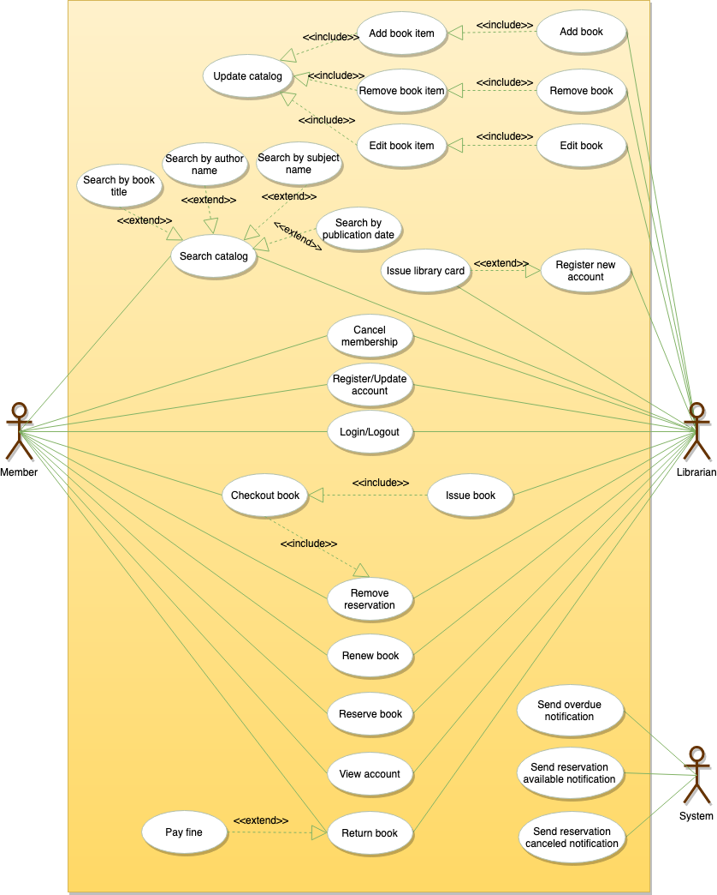

**II.ER Diagrams:**

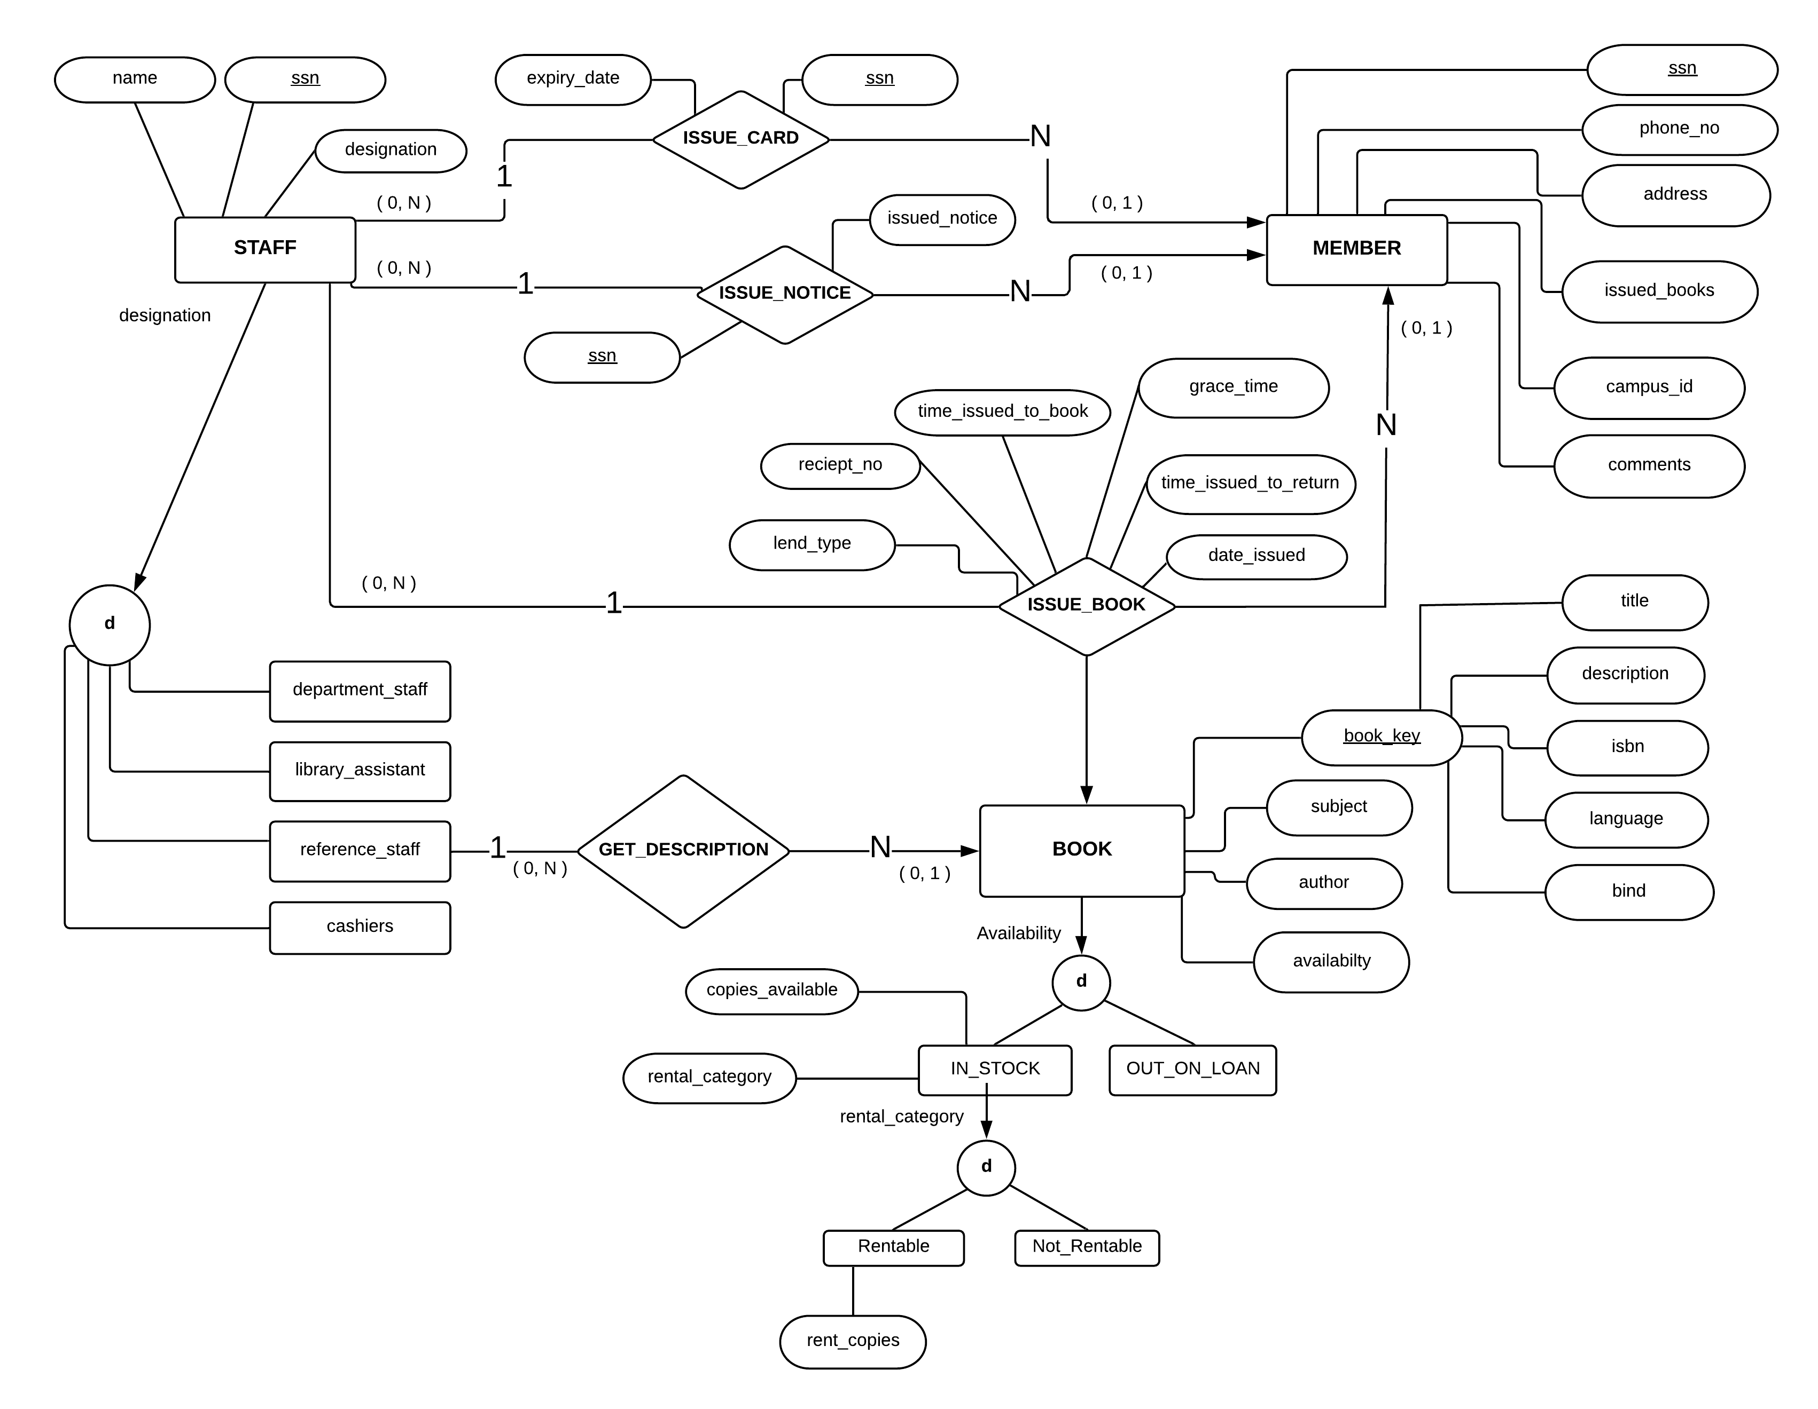

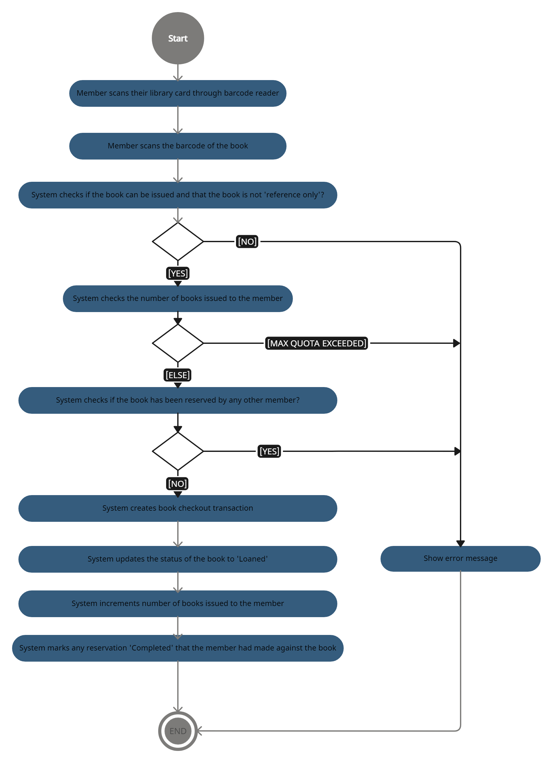**IV.Activity Diagrams:**

**V.Class diagram :**

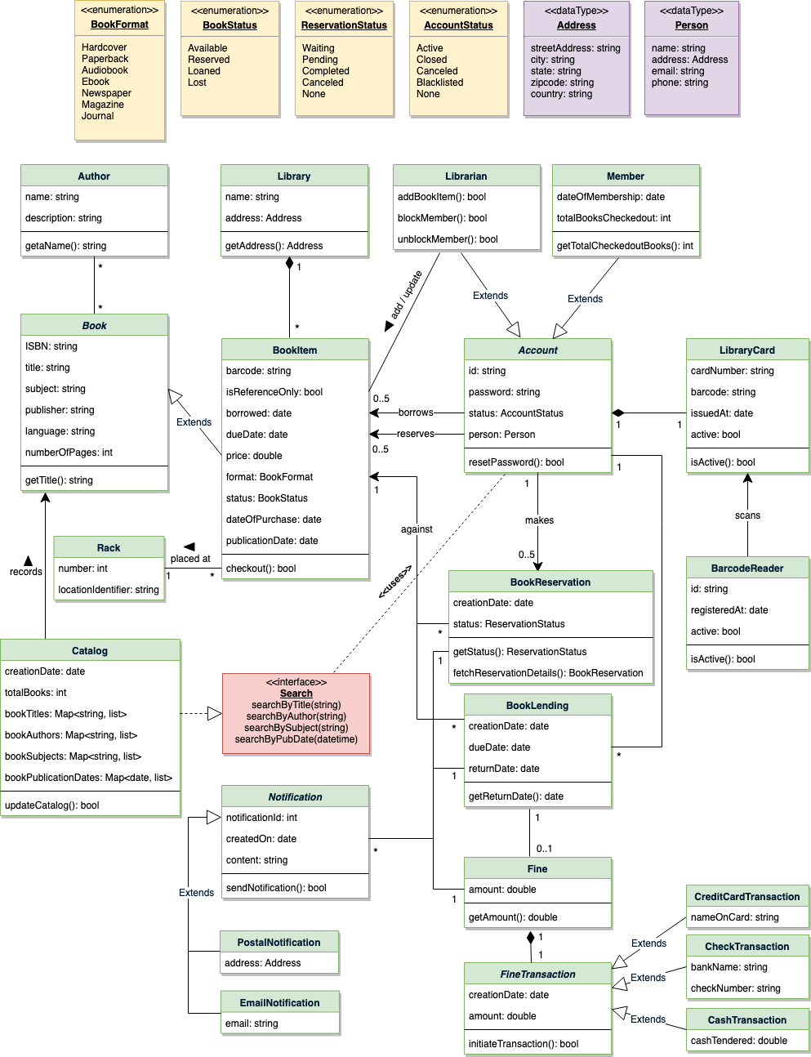

## Table Name : lms_admin

|  |  |  |  |  |
| --- | --- | --- | --- | --- |
| **Field** | **Type** | **Null** | **Key** | **Extra** |
| admin_id | int(11) | NO | PRI | auto_increment |
| admin_email | Varchar(40) | NO |  |  |
| admin_password | Varchar(16) | NO |  |  |

1. **Table Name: lms_author**

|  |  |  |  |  |
| --- | --- | --- | --- | --- |
| **Field** | **Type** | **Null** | **Key** | **Extra** |
| author_id | int(11) | NO | PRI | auto_increment |
| author_name | varchar(30) | NO |  |  |
| author_status | enum(0,1) | NO |  |  |
| author_created_on | timestamp | NO |  | DEFAULT_GENERATED |
| author_updated_on | timestamp | NO |  | DEFAULT_GENERATED |

|  |  |  |  |  |
| --- | --- | --- | --- | --- |
| **Field** | **Type** | **Null** | **Key** | **Extra** |
| book_ID | int | NO | PRI | auto_increment |
| book_category | varchar(30) | NO |  |  |
| book_author | varchar(40) | NO |  |  |
| book_location_rack | varchar(40) | NO |  |  |
| book_name | text | NO |  |  |
| book_isbn_number | varchar(30) | NO |  | DEFAULT_GENERA TED |
| book_no_of_copy | int(5) | NO |  |  |
| book_status | Enum(0,1) | NO |  |  |
| book_added_on | timestamp | NO |  |  |
| book_updated_on | timestamp | NO |  | DEFAULT_GENERA TED |

|  |  |  |  |  |
| --- | --- | --- | --- | --- |
| **Field** | **Type** | **Null** | **Key** | **Extra** |
| category_id | int(11) | NO | PRI | auto_increment |
| category_name | varchar(30) | YES |  |  |
| category_status | Enum(0,1) | YES |  |  |
| category_created_on | timestamp | YES |  | DEFAULT_GENERATED |
| category_updated_on | timestamp | YES |  | DEFAULT_GENERATED |

## 5. Table Name: lms_issue_book

|  |  |  |  |  |
| --- | --- | --- | --- | --- |
| **Field** | **Type** | **Null** | **Key** | **Extra** |
| issue_book_id | int(11) | NO | PRI | auto_increment |
| book_id | varchar(30) | NO | FK |  |
| user_id | varchar(30) | NO | FK |  |
| issue_date_time | varchar(30) | NO |  |  |
| expected_return_date | varchar(30) | NO |  |  |
| return_date_time | varchar(30) | NO |  |  |
| book_fines | varchar(30) | NO |  |  |
| book_issue_status | Enum(-1,0,1) | YES |  |  |

|  |  |  |  |  |
| --- | --- | --- | --- | --- |
| **Field** | **Type** | **Null** | **Key** | **Extra** |
| location_rack_id | int(11) | NO | PRI | auto_increment |
| location_rack_name | varchar(30) | YES |  |  |
| Location_rack_status | Enum(0,1) | NO |  |  |
| location_rack_created_0n | timestamp | YES |  | DEFAULT_GENERATED |
| location_rack_updated_on | timestamp | YES |  | DEFAULT_GENERATED |

**7. Table Name: lms_setting**

|  |  |  |  |  |
| --- | --- | --- | --- | --- |
| **Field** | **Type** | **Null** | **Key** | **Extra** |
| seeting_id | int | NO | PRI | auto_increment |
| library_name | varchar(30) | NO |  |  |
| library_address | text | NO |  |  |
| library_contact_number | varchar(30) | NO |  |  |
| library_email_address | varchar(30) | NO |  |  |
| library_total_book_issued_day | int(5) | NO |  |  |
| library_one_day_fine | Decimal(4,2) | NO |  |  |
| library_issue_total_book_per_user | int(3) | NO |  |  |
| library_currency | varchar(30) | NO |  |  |
| library_timezone | varchar(100) | NO |  |  |

## Home Page :

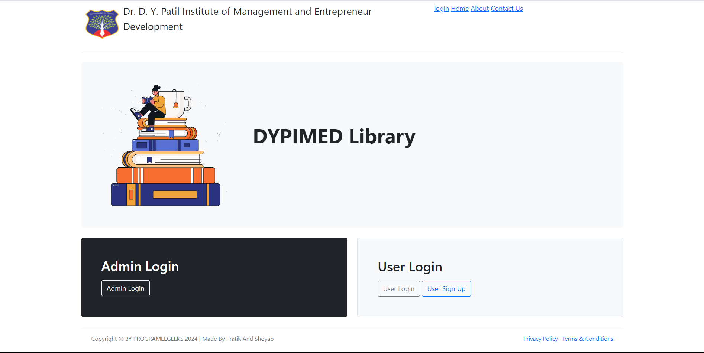

**Registration Page :**

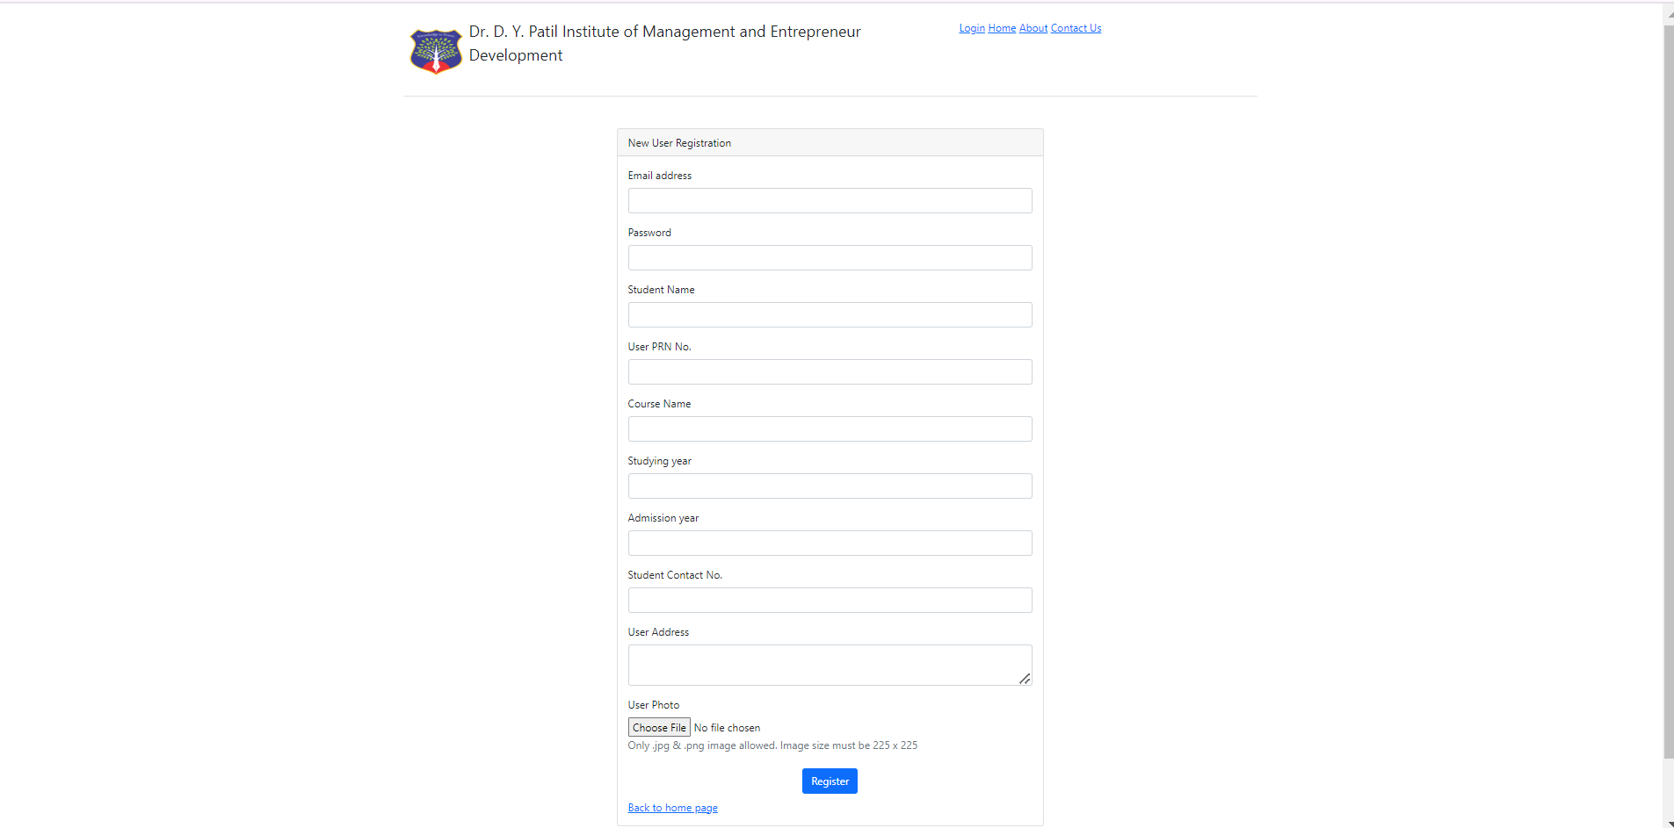

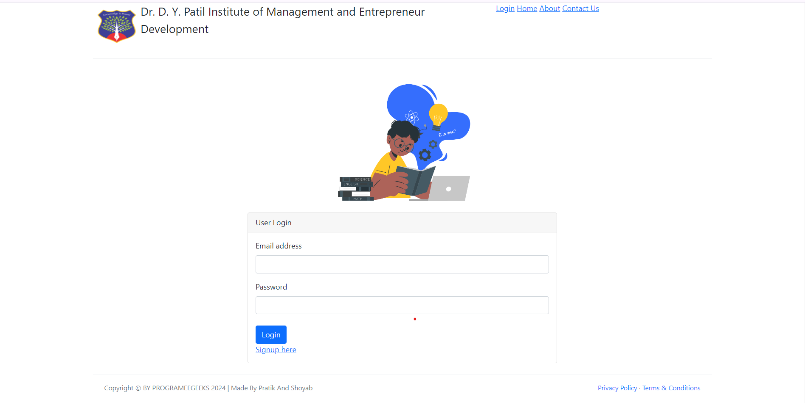

## Admin Login:

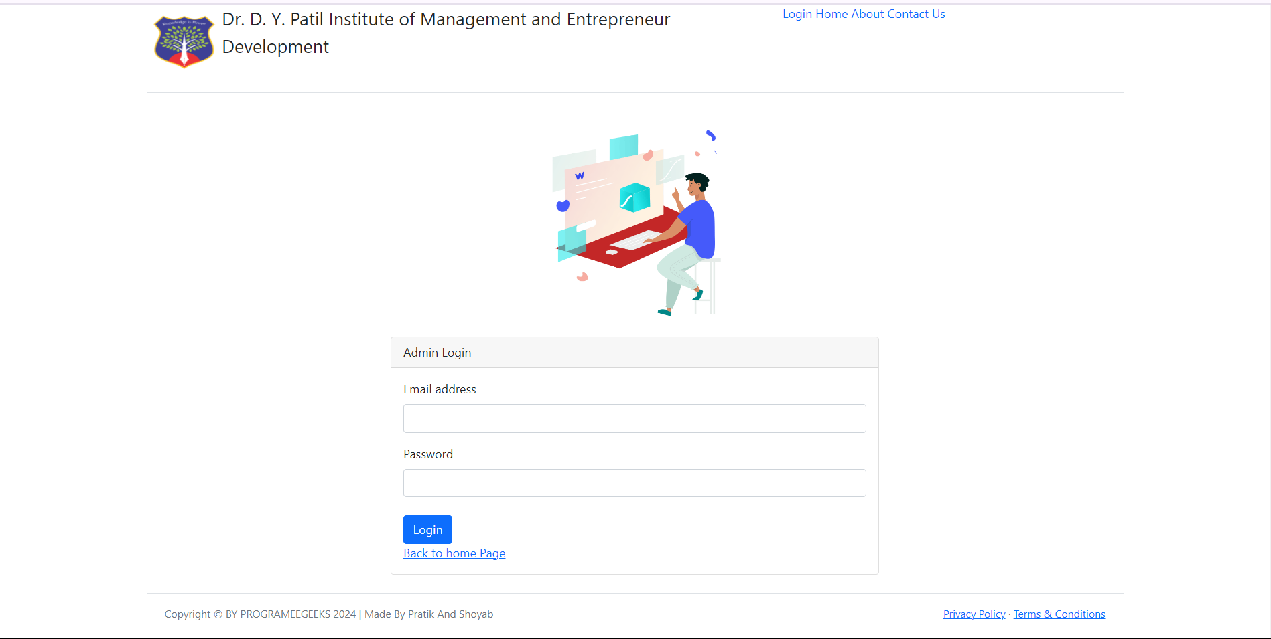

**Admin Dashboard :**

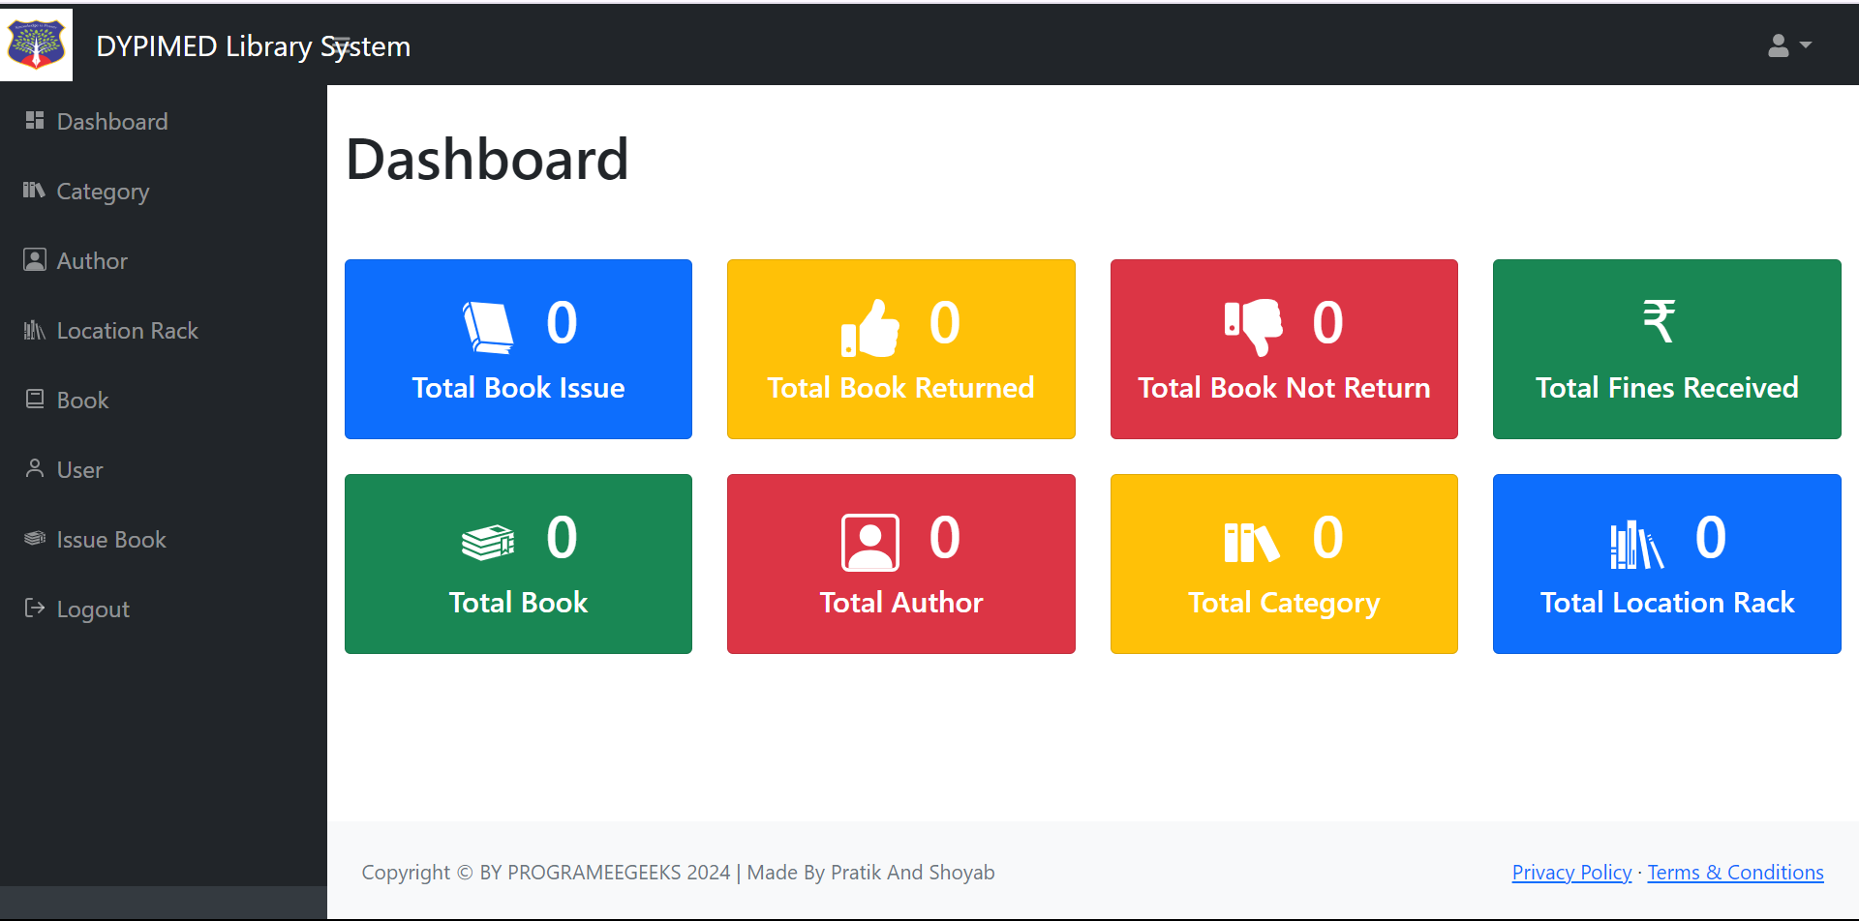

**Add/Manage categories :**

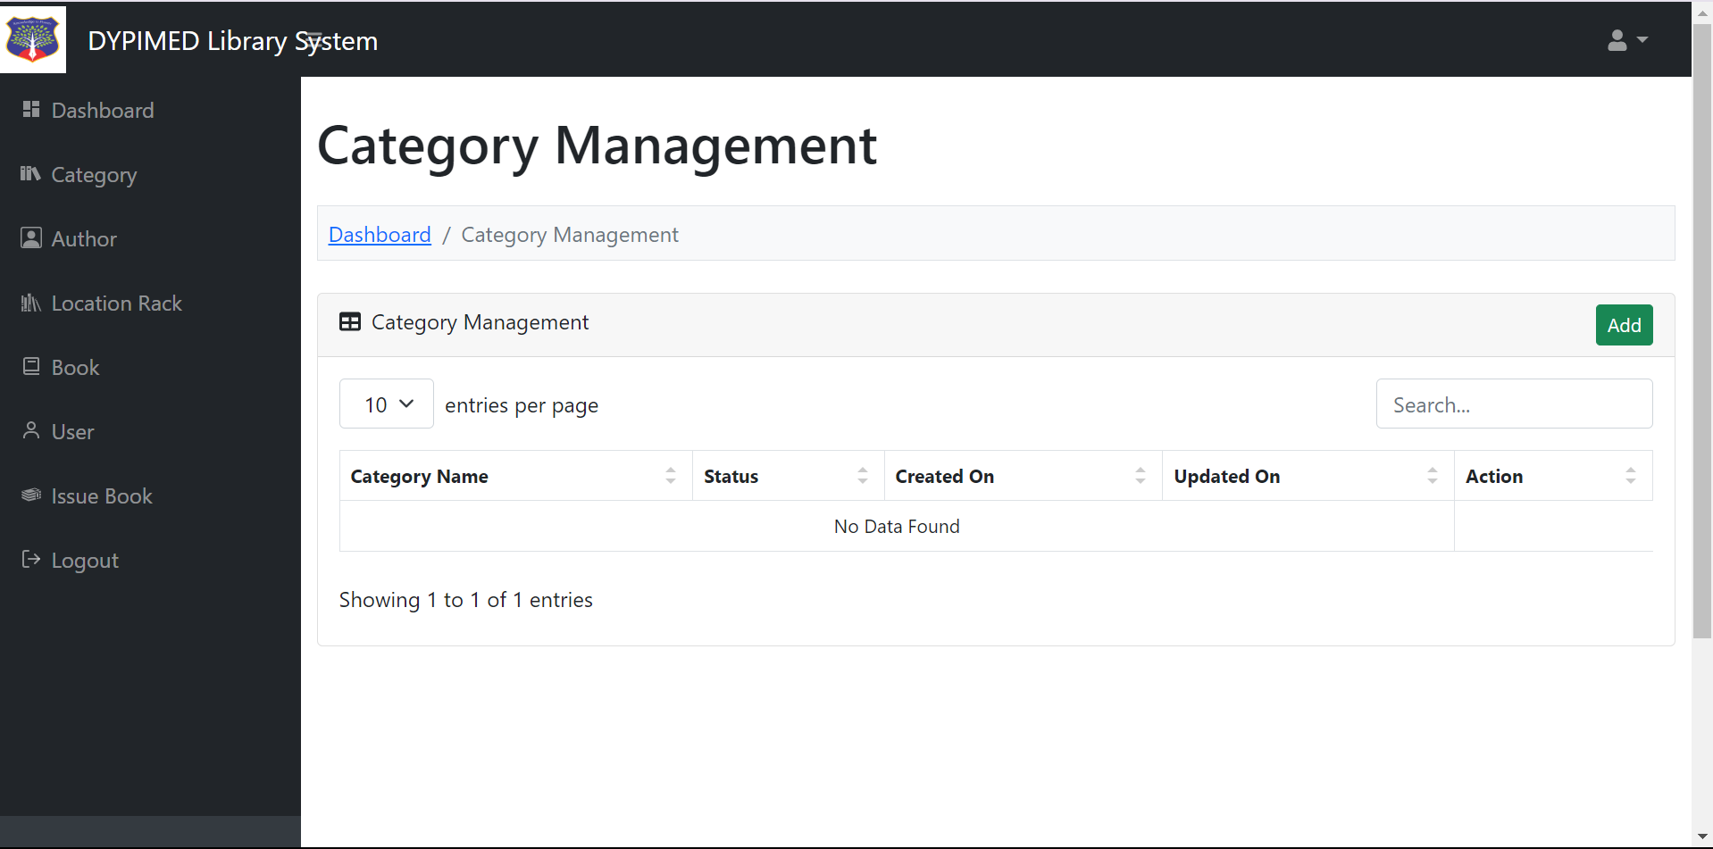

**Add/Manage Location Rack :**

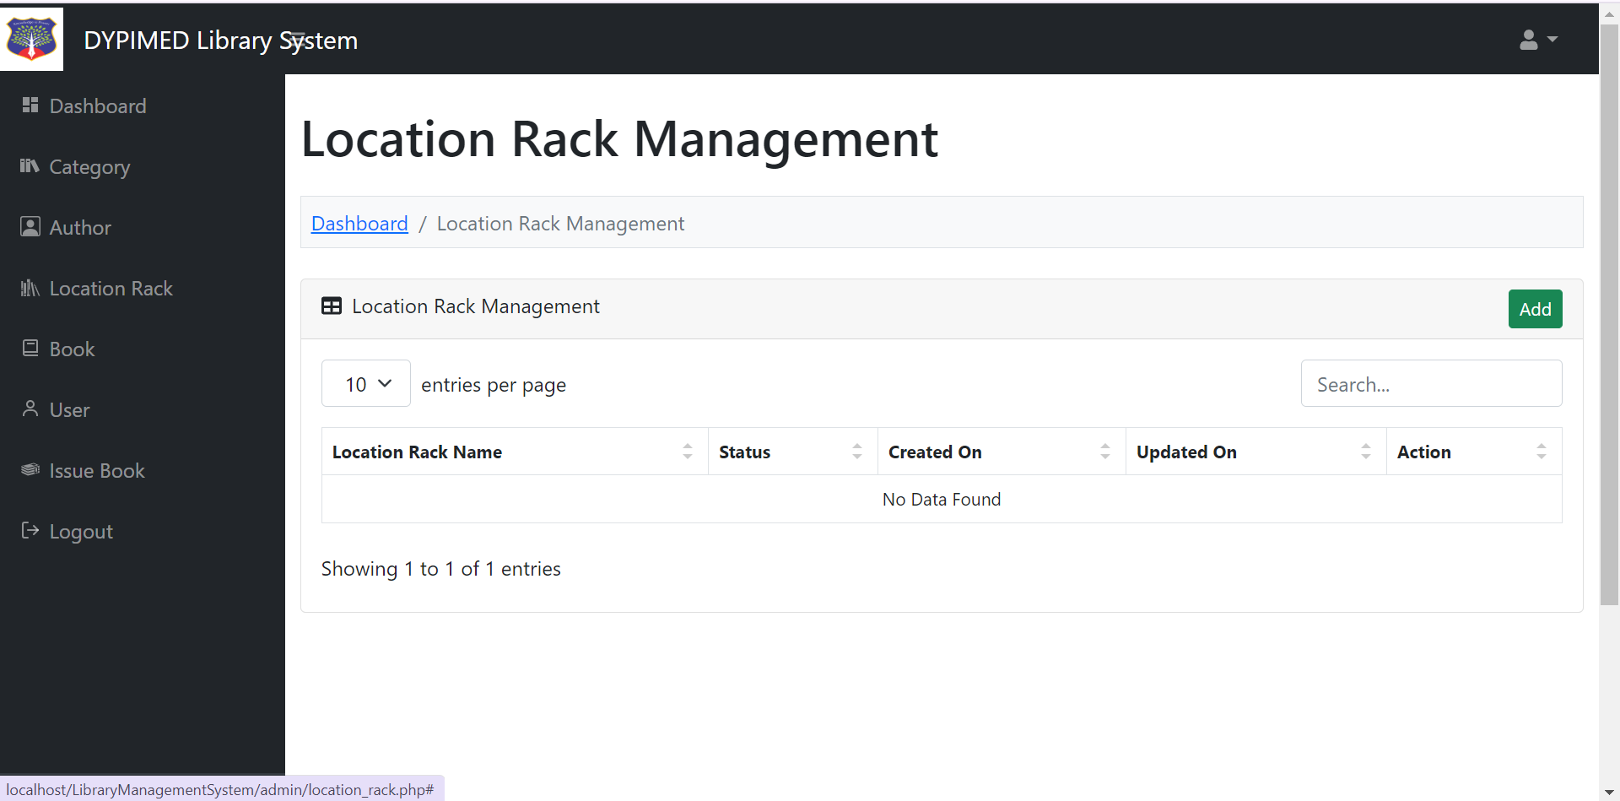

**Add/Manage Books :**

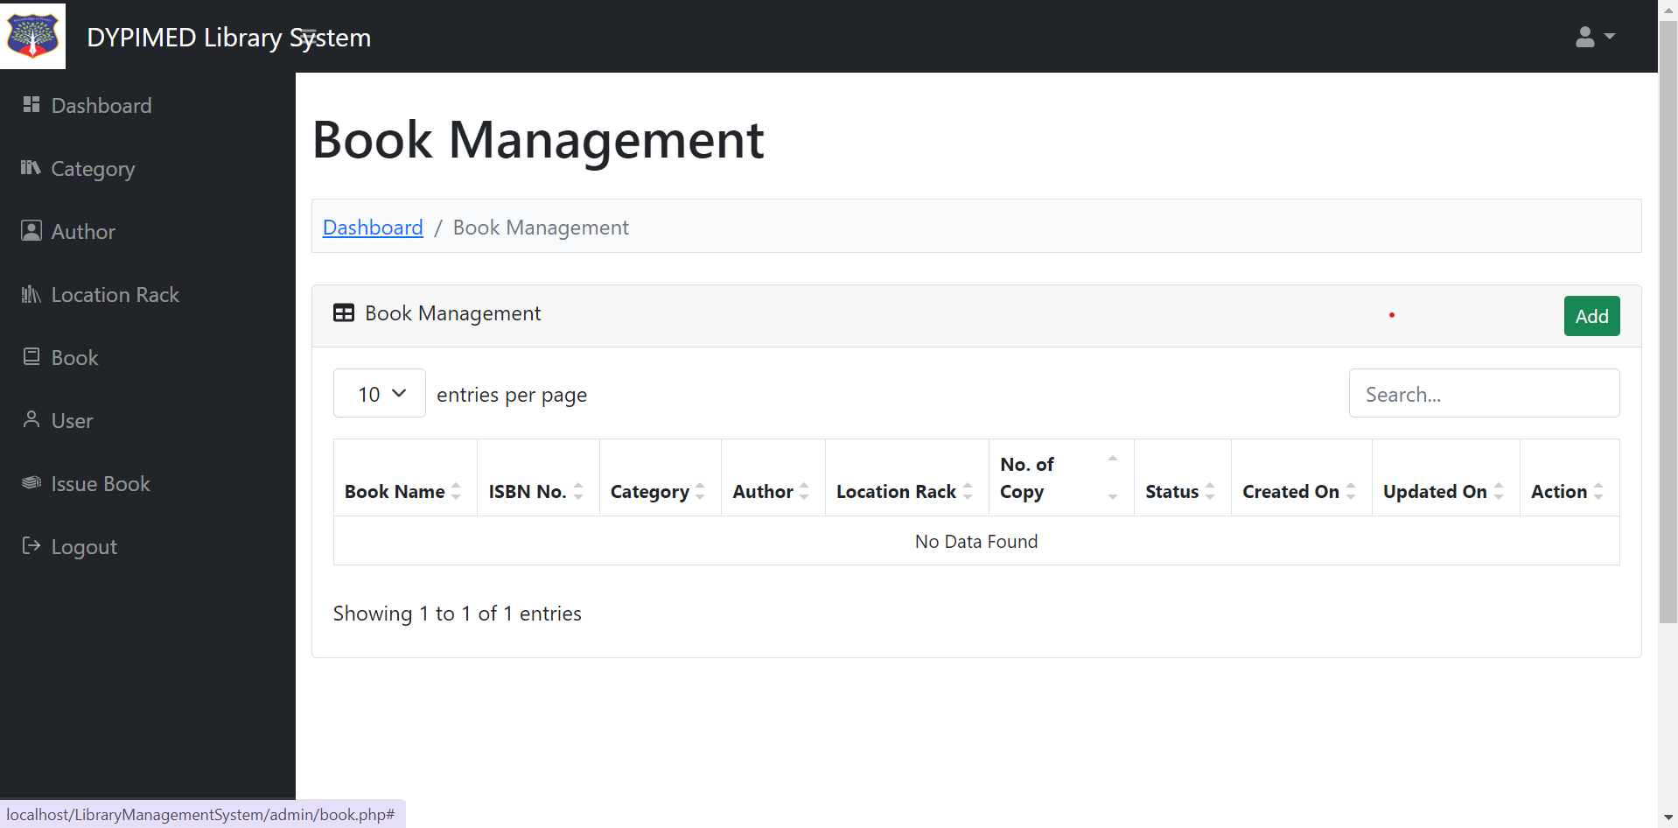

**Add/Manage categories :**

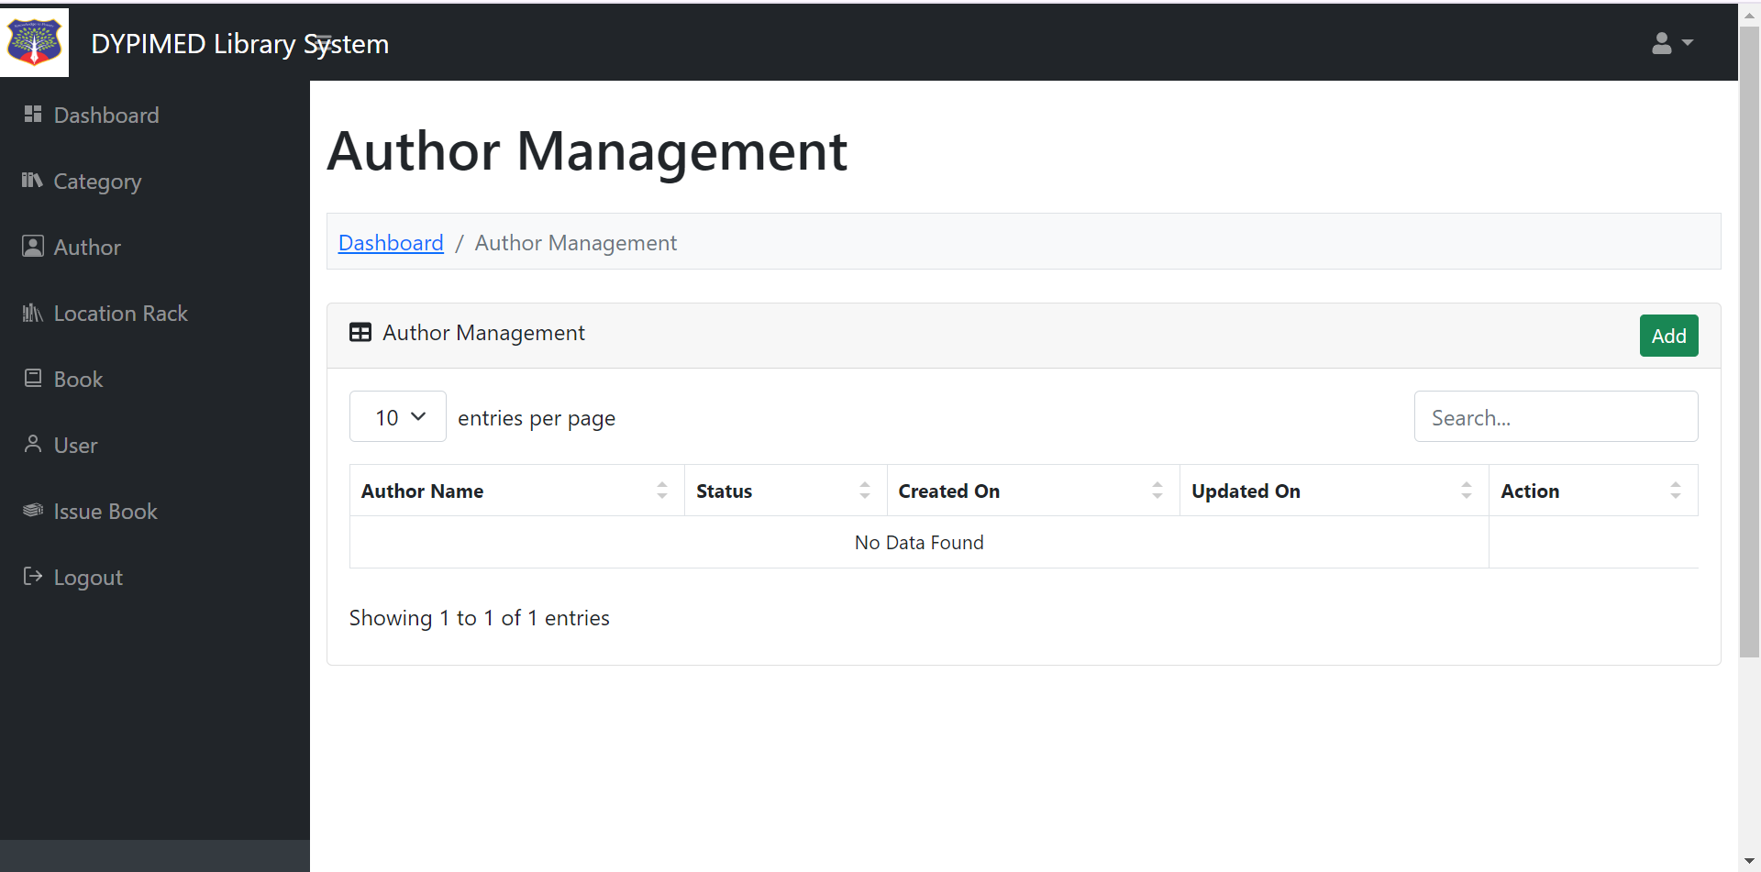

**Add/Manage categories :**

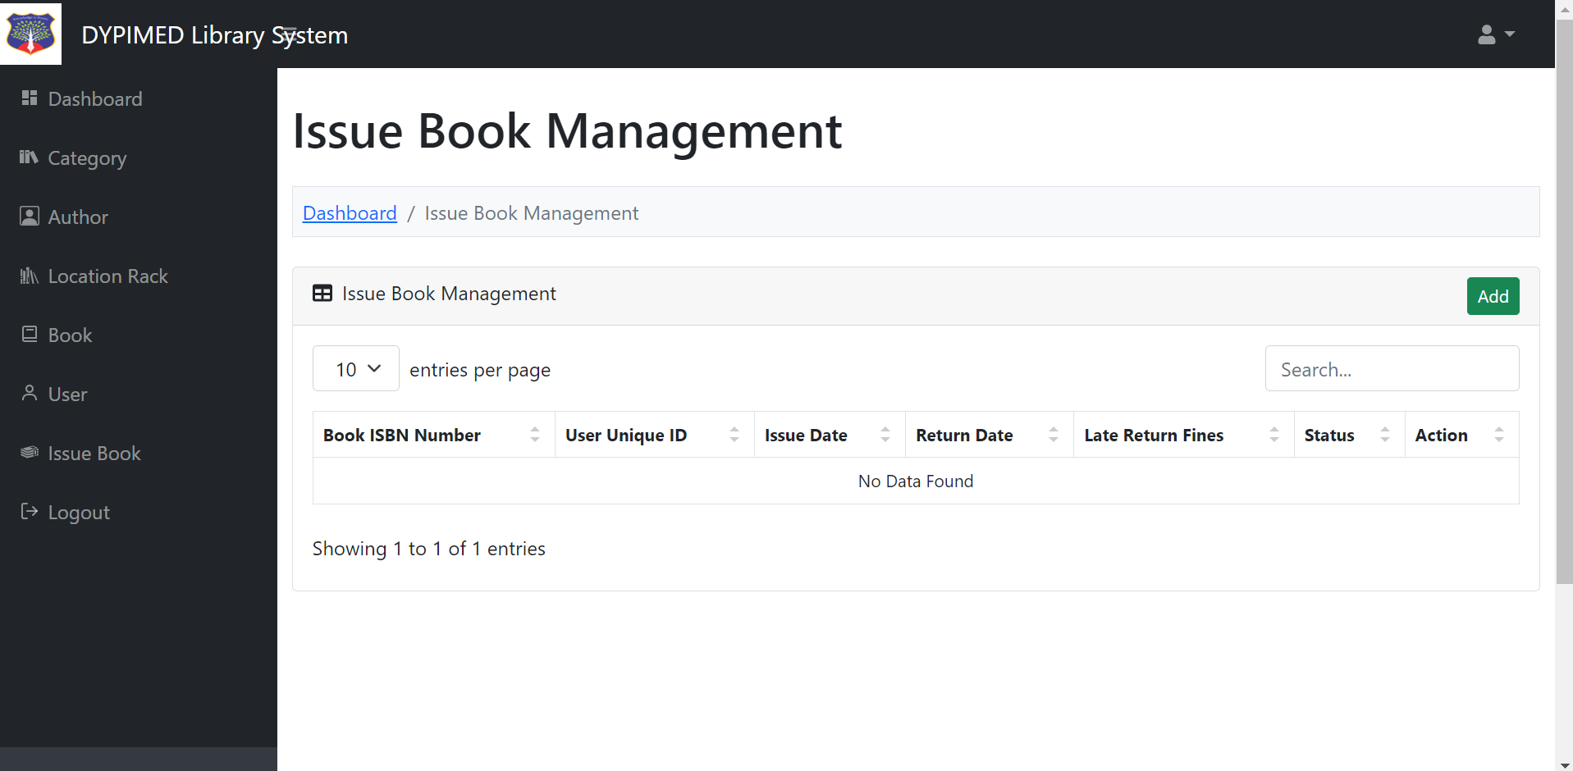

## Testing

* 1. **Testing Strategy**

### Objective:

Ensure the system meets functional and non-functional requirements. Identify and resolve defects before deployment.

Validate the system's performance, security, and usability.

### Scope:

Specify what will be tested and what won't be tested. This includes identifying the features, functionalities, platforms, and environments to be covered by testing.

### Test Levels:

* **Unit Testing**: Testing individual components or modules in isolation to ensure they function correctly.
* **Integration Testing**: Testing the interaction between integrated components/modules to verify they work together as expected.
* **System Testing**: Testing the complete system to validate it meets specified requirements and behaves as intended.
* **Acceptance Testing**: Testing conducted by end-users or stakeholders to determine whether the software meets acceptance criteria.

### Test Techniques:

* **Black Box Testing**: Testing without knowledge of the internal workings of the system.
* **White Box Testing**: Testing based on an understanding of the internal logic and code structure.
* **Regression Testing**: Testing to ensure that changes or enhancements have not adversely affected existing functionality.

### Test Environment:

* Identify the hardware, software, and network configurations required for testing.
* Specify any test data or test tools needed for executing tests.

### Test Deliverables:

* Define the documents and artifacts that will be produced during testing, such as test plans, test cases, test reports, and defect logs.

### Test Execution:

* Describe how tests will be executed, including the schedule, responsibilities, and resources required.
* Specify any automated testing tools or frameworks that will be used.

## Unit Test Plan :

## A ****Unit Test Plan**** for the Library Management System (LMS) is designed to verify the functionality of individual units (or components) within the system, typically focusing on small, isolated functions or methods. The primary goal is to ensure that each unit operates correctly, independent of other components.

### Introduction

**Purpose**

The purpose of this unit test plan is to outline the approach, scope, resources, and schedule for unit testing the library management system(LMS) to ensure each individual component functions correctly.

### Scope

This test plan will cover core units of the LMS including, but not limited to:

* **User Management Functions** (registration, login, user profile management)
* **Catalog Management Functions** (add, update, delete books/resources)
* **Transaction Management Functions** (borrow, return, check availability)
* **Notification Functions** (due reminders, overdue alerts)
* **Search Functionality** (search for books/resources by keyword, author, title)
* **Report Generation Functions** (borrowing history, inventory reports)
* **Security and Access Control Functions** (user authentication, role-based access)

### Test Objectives

* + - * The objective of the Unit Test Plan is to validate that individual functions, methods, and classes in the LMS work as expected.
      * Unit tests are conducted early in the development cycle to identify and fix issues before they become part of the integrated system. T
      * hese tests ensure accuracy, reliability, and correctness in foundational code components.

### Test Environment

Development Environment:

IDE: Visual Studio Code, IntelliJ IDEA, or other relevant IDEs.

Programming Language: PHP, JavaScript, html,css,bootstrap or the language used in the project.

### Test Scope

* + - * Modules to be Tested
      * User Management
      * User Registration
      * User Login/Logout
      * Profile Management
      * User Management
      * User Creation
      * User Updating
      * User Deletion
      * Booking Creation
      * Booking Modification
      * Booking Cancellation

### Test Data

|  |  |  |  |
| --- | --- | --- | --- |
| **Test Case ID** | **Functionality** | **Input** | **Expected Result** |
| **UT01** | User Registration | New user details | Successful registration, confirmation message |
| **UT02** | User Login | Valid username and password | User is logged in, session created |
| **UT03** | User Login | Invalid username or password | Error message displayed, user not logged in |
| **UT04** | Add Book | Valid book details | Book is added to catalog, confirmation message |
| **UT05** | Delete Book | Valid book ID | Book is removed from catalog, confirmation message |
| **UT06** | Borrow Book | Valid book ID, available quantity | Book status updated to borrowed, due date assigned |
| **UT07** | Borrow Book | Book with 0 available quantity | Error message displayed, transaction denied |
| **UT08** | Return Book | Valid book ID | Book status updated to available, due date cleared |
| **UT09** | Search Book | Title keyword | List of books matching keyword displayed |
| **UT10** | Notification Reminders | Book due date passed | Reminder notification sent to user |
| **UT11** | Generate Inventory Report | N/A | Inventory report generated with correct data |
| **UT12** | Access Control | Unauthorized access attempt | Access denied, error message displayed |

### Test Execution

**Preparation**:

* The function or module has been coded and passes preliminary development checks.
* All dependencies required for the unit are ready for testing or can be mocked.

**Execution**:

* + All test cases have been executed.
  + All critical and high-severity issues are resolved.
  + Each unit achieves at least 90% code coverage to ensure thorough testing.

### An ****Acceptance Test Plan**** for a Library Management System (LMS) outlines the strategy for verifying that the LMS meets the library’s requirements and is ready for deployment. The plan ensures that the system aligns with end-user expectations, functional specifications, and system performance benchmarks.

### Scope:

The test plan focuses on core functionalities of the LMS, including:

* **User Registration and Authentication**
* **Catalog Management** (adding, updating, deleting books/resources)
* **Borrowing and Returning Resources**
* **Notifications and Reminders**
* **Search and Reserve Functionality**
* **Reporting and Analytics**
* **Admin and User Interface**

### Test Objectives

* + The primary objective of the Acceptance Test Plan is to ensure that the LMS meets all functional, technical, and performance requirements.
  + The test verifies that the system is reliable, user-friendly, and adequately fulfills the needs of library staff and patrons.
  + Acceptance criteria include accuracy in cataloging, ease of use in resource management, secure user authentication, and reliable reporting features.

### Acceptance Criteria

Each module will be evaluated based on the following criteria:

* **Functional Accuracy**: Each module should function according to requirements.
* **User Experience**: Interfaces should be intuitive, with smooth navigation and quick response times.
* **Performance**: The system should handle the expected number of users and transactions without degradation.
* **Security and Data Privacy**: The system must protect user data and maintain secure access.
* **Compliance**: System must comply with data privacy regulations and library policies.

### Test Environment

Testing will be conducted on a server configuration that matches the library’s production environment to ensure accurate results. Test accounts for library staff and patrons will be used to simulate real-world interactions.

### Test Data

|  |  |  |
| --- | --- | --- |
| **Test Scenario** | **Test Case ID** | **Expected Result** |
| **User Registration and Login** | **TC01** | Successful account creation and secure login. |
| **Catalog Management** | **TC02** | Librarians can add, update, and remove resources. |
| **Borrowing and Returning** | **TC03** | Patrons can borrow/return books with accurate tracking. |
| **Notifications** | **TC04** | Automated reminders for due dates and fines sent. |
| **Search and Reserve** | **TC05** | Users can search the catalog and reserve books. |
| **Report Generation** | **TC06** | Admins can generate accurate reports on resources. |
| **Security Checks** | **TC07** | System prevents unauthorized access. |

A Library Management System (LMS) offers many advantages, enhancing library efficiency, improving user access, and supporting data-driven management. Here are the key benefits:

### 1. ****Automation of Routine Tasks****

* + **Efficient Borrowing and Returning**: An LMS automates check-in/check-out, reducing manual work for staff and minimizing errors in the lending process.
  + **Automatic Reminders and Fines**: Notifications for due dates, overdue items, and fines are sent automatically, improving the timeliness of returns and reducing the burden on staff.

### 2. ****Enhanced User Experience****

* + **Easy Resource Access**: Users can search, reserve, and renew materials online, making it convenient to access library resources without needing to visit physically.
  + **Personalized Accounts**: Patrons can manage their accounts, view borrowing history, and reserve items from any device, enhancing engagement and user satisfaction.

### 3. ****Real-Time Inventory Management****

* + **Accurate Resource Tracking**: The system maintains up-to-date records of available, reserved, checked-out, and lost items, improving resource management.
  + **Inventory Optimization**: By tracking resource usage patterns, the LMS helps identify underused or high-demand items, informing future acquisition decisions.

### 4. ****Integration of Digital and Physical Resources****

* + **Unified Catalog**: Both physical and digital resources, such as e-books and online journals, are available in a single catalog, making it easier for users to find the resources they need.
  + **Digital Resource Management**: The LMS provides controlled access to e-resources, helping libraries meet the needs of patrons who prefer digital content.

### 5. ****Data-Driven Decision Making****

* + **Detailed Analytics**: Usage data, borrowing trends, peak times, and patron demographics provide insights for improving services and resource allocation.
  + **Customizable Reports**: Administrators can generate reports on user activity, popular resources, and overdue rates, helping guide decisions in acquisitions, budget allocation, and staffing.

### 6. ****Improved Communication and Notifications****

* + **Automated Notifications**: Patrons receive reminders and alerts via email or SMS for reservations, due dates, or overdue items, which helps prevent fines and keeps users engaged.
  + **Enhanced User Communication**: The system’s notification capabilities make it easy to inform patrons about library events, new acquisitions, or changes in library hours.

### 7. ****Security and Data Integrity****

* + **Data Protection**: The LMS employs secure access controls, protecting patron data and transaction records against unauthorized access.
  + **Backup and Recovery**: Many LMS solutions offer backup and recovery options, ensuring that library data remains intact in case of a system failure or other issues.

### 8. ****Operational Cost Reduction****

* + **Reduced Manual Work**: By automating processes, the LMS reduces staffing needs for routine tasks, freeing up resources for other library functions.
  + **Minimized Resource Loss**: The LMS helps track items more effectively, reducing cases of lost or misplaced resources, which saves costs in replacements.

### 9. ****Scalability and Flexibility****

* + **Adaptable System**: Most LMS solutions are modular and can be expanded to meet the growing needs of a library, including new locations, increased collections, or additional services.
  + **Future-Ready**: An LMS can integrate with new technologies, such as mobile apps or advanced analytics, ensuring the library remains relevant and capable of meeting modern demands.

### 10. ****Supports Digital Transformation****

* + **Enhanced Online Presence**: With an LMS, libraries can offer digital services that meet the expectations of tech-savvy patrons, especially important for academic and research libraries.
  + **Digital Literacy Support**: Libraries can use the LMS to support digital resources, encouraging digital literacy and making the library a valuable community tech resource.

While a Library Management System (LMS) brings numerous advantages, there are also several potential disadvantages to consider:

### 1. ****High Initial Cost****

* + **Implementation Costs**: Custom-built or proprietary LMS solutions can be costly to implement, requiring investment in software licensing, hardware upgrades, and initial setup.
  + **Infrastructure Upgrades**: In some cases, existing library infrastructure may need significant upgrades to accommodate a new LMS, especially if new hardware like barcode scanners or RFID systems are required.

### 2. ****Maintenance and Operational Costs****

* + **Ongoing Expenses**: The system may require regular maintenance, updates, and technical support, which can add to operational costs.
  + **Subscription or Licensing Fees**: Many LMS platforms, especially proprietary systems, come with recurring costs that can strain library budgets over time.

### 3. ****Complexity and Learning Curve****

* + **Staff Training Requirements**: Library staff may need substantial training to learn and efficiently use the LMS, especially if it has a range of complex features.
  + **User Adaptation**: Patrons who are less familiar with digital tools or technology may struggle initially with navigating the system, requiring additional support from library staff.

### 4. ****Technical Dependence and Downtime****

* + **System Downtime**: Since the LMS is a digital system, it is vulnerable to technical issues, such as server failures, software glitches, or internet connectivity issues, which can disrupt library operations.
  + **Dependence on IT Support**: The library may need continuous IT support to manage and troubleshoot the system, particularly if it encounters frequent issues or updates.

### 5. ****Data Security and Privacy Concerns****

* + **User Data Vulnerability**: Storing personal and borrowing data digitally introduces the risk of unauthorized access, data breaches, or cyberattacks, which could compromise user privacy.
  + **Compliance Requirements**: Libraries may face challenges in ensuring compliance with data privacy laws, which require robust data protection measures and regular audits.

### 6. ****Customization Limitations****

* + **Flexibility**: Many proprietary LMS solutions may not be easily customizable to meet specific library needs, which can limit their ability to fully address unique requirements or workflows.
  + **Dependency on Vendor**: In proprietary systems, libraries may become dependent on the vendor for customizations, updates, and support, which can lead to delays or increased costs.

In conclusion, implementing a Library Management System (LMS) offers a transformative solution for modernizing and streamlining library operations. This feasibility study shows that the LMS is a viable project across technical, economic, operational, and schedule aspects, providing a clear path for enhancing efficiency, accessibility, and resource management within the library. By automating processes such as cataloging, inventory tracking, user management, and notifications, the LMS significantly reduces manual workload, enabling library staff to focus more on serving patrons effectively.

* + [www.google.com](http://www.google.com/)
  + [www.youtube.com](http://www.youtube.com/)
  + [http://www.phpworld.com](http://www.phpworld.com/)
  + [www.w3school.com](http://www.w3school.com/)
  + **BOOKS:**
    - 1. **Database System Concepts:**

**B**y Abraham Silberschatz ,Henry F. Korth and S. Sudarshan

**2) Software Engineering:**

By S. chand

**3) PHP andMYSQL Novice to Ninja:**

By Kevin Yank